Freshmen Summer Internship Program 2013

Assignment 2

**Topic SSB and LV Safety**

The rules are same as the previous assignment. In case you have forgotten, they are listed below as well.

* This assignment is divided into four parts – A - SSB (Basic), B - SSB (Advanced), C - LV safety (Basic) and D - LV Safety (Advanced)
* Everyone has to attempt both the basic sections (A&C)
* Everyone has to attempt advance section ( B or D) of their subsystem; i.e. Mechanical guy has to attempt advanced mechanical section (B) and electrical guy has to attempt advanced electrical section (D)
* If you wish to attempt another advanced section as well, no one’s stopping you. But, that shall be acknowledged and encouraged only if you do justice with your subsystem
* While we seriously encourage healthy discussions, we do condemn plagiarism. Come on man ! We work so hard designing these assignments to teach you. Don’t do this to us !!
* Feel free to approach any senior any time of the day – for queries, doubts or trash talk; we are always open.
* Don’t forget to list the references at the end of your assignment
* Keep in mind that an image is worth thousand words
* Enjoy your assignment !!

Submission deadline – 11:59 PM, 16/5/2013

**Section A - SSB (Basic)**

1. Explain the following in brief (Neat explanation with a diagram) : Understeer & Oversteer.
2. When we apply brakes, what exactly stops the car- the frictional force acting between brake discs and pads or friction acting between ground and tires? Explain.
3. Explain Ackermann geometry with the help of a diagram. Ackermann geometry is applicable only to very low lateral accelerations. For high lateral accelerations, Ackermann geometry fails to give satisfactory results. What could be the reason (explain in brief)?
4. What are the most important properties of a brake fluid? You must have seen the metallic brake lines used in our car. Why do you think we chose metallic lines instead of rubber brake lines? Afterall, rubber lines would have been much easier to bend and install!
5. a) Under what assumptions is a suspension linkage a two-force member?

b) What is an Instantaneous Centre of Rotation and what is its significance. Explain briefly.

**Section B SSB (Advanced)**

**1**. A stationary car of mass 300 kg is being supported by four wheels.

Assumptions:

* Each wheel supports equal load
* There is no slipping at any wheel
* There is no compliance or play in the steering system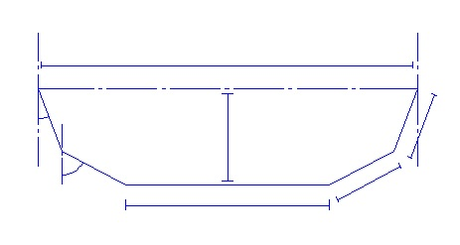

Rack

Steering Arm

Tie Rod

α

SA

β

For the above steering geometry, following quantities are given:

* Coefficient of static friction (µ) is 1.4
* Mechanical trail is 14 mm
* Steering arm length = SA = 68.8 mm
* α = 20o
* β = 86o
* Effective pinion diameter = 33 mm

Now, our driver Mudit wants to calculate the amount of driver feedback or self aligning torque he will be experiencing. Unfortunately, none of the sophies or thirdies are available and none of the fourthies are able to calculate(:P). Thus, you guys have been entrusted with this herculean task. Using the given information and pictures, help out Mudit!

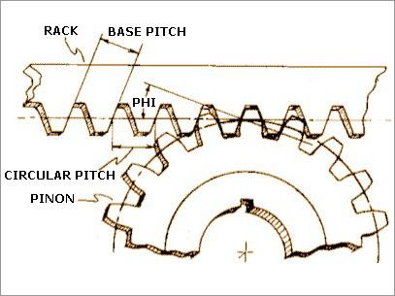

Effective pinion radius

**2**. In order to model the spring damper system, people generally use the simplest option available which is the 2 DOF quarter car model. The schematic of the same is given below-

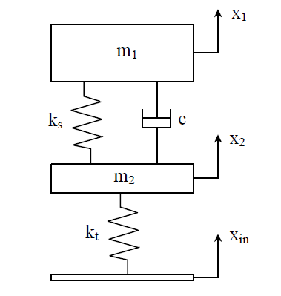

In the above figure, m2 = Unsprung mass

m1 **=** Sprung mass

ks = Spring stiffness

kt = Tire stiffness

c = Damping coefficient

Xin = displacement input

X1 = Displacement of sprung mass

X2 = Displacement of unsprung mass

Transmissibility is defined as the ratio of displacement of a given body to displacement input. Assume Xin to be a sinusoidal wave of a given amplitude with a variable frequency. The following parameters are given:

m1 = 43 kg

m2 = 4.5 kg

ks = 3500 N/m

kt = 19000 N/m

Plot two graphs which shows the transmissibility of sprung mass and unsprung mass on the Y- axis and frequency of sinusoidal displacement input on X- axis for damping ratios 0.1, 0.3, 0.5, 0.7 & 0.9 where damping ratio is defined as the ratio of damping coefficient and critical damping coefficient(Refer Wikipedia for more info on damping ratio). Explain your results.

**Section C Electrical (Basic)**

1. What is LV safety system?

2. Why is LV safety important in EVo 2?

3. What is the purpose of

* TSAL
* RTDS
* BOTS
* Ground fault detector
* Inertia switch
* Kill switch – why there are 3 of these mounted at different position in the car?

4. EV2.3.4 “Atleast two separate sensors have to be used as torque encoders (throttle position sensors)” – Ref. FSAE Rulebook 2013. Why do you think this rule is necessary?

**Section D Electrical (Advanced)**

1. Design a schematic of a functional LV safety system for EVo 2 on paper. Clearly indicate the chip components (resistors, capacitors, IC name that you are using).

2. CAD the XLR8 motor driving circuit on EAGLE.